Data Set

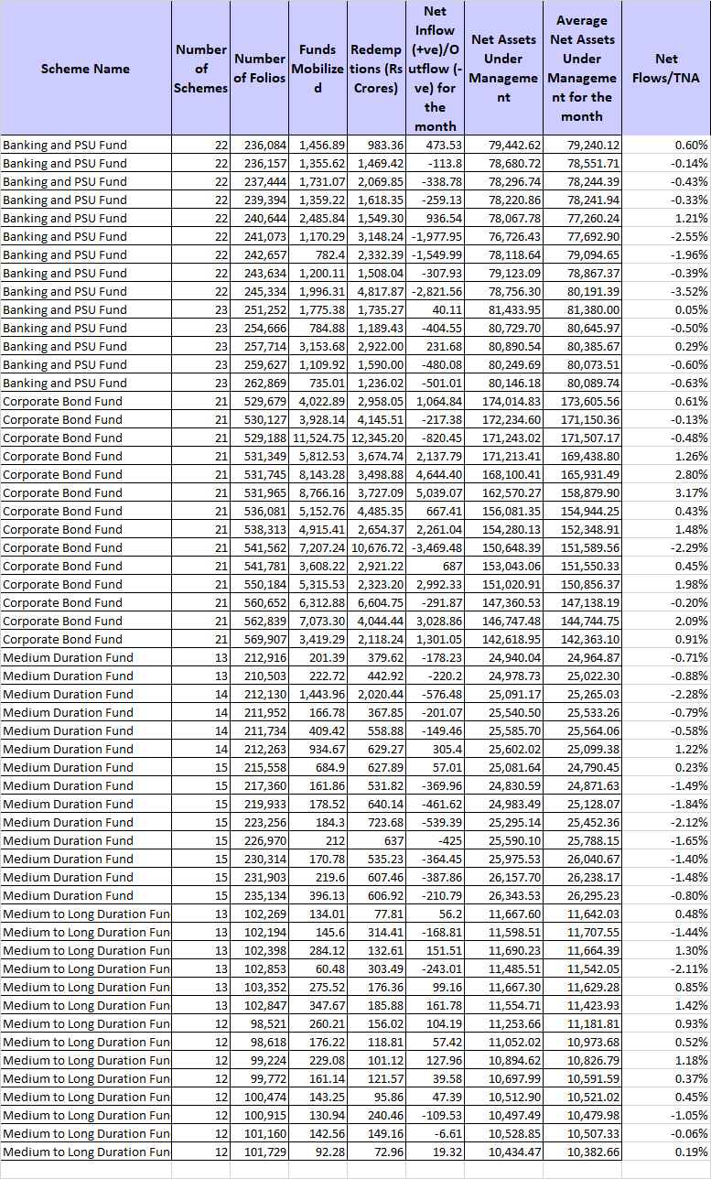

**Python Code**

#Program for VaR calculation of liquidity Debt Funds

import numpy as np

import pandas as pd

import matplotlib.pyplot as plt

from scipy.stats import norm

##Mount your data here eg df=pd.read_csv('fundstressdata.csv')

y=df.iloc[:,8]

#I’ve used the position in which TNA is in the csv above

confidence_level = 0.95

z_score = norm.ppf(1 - confidence_level)

means= np.mean(y)

std_dev = np.std(y)

print(std_dev)

VaR_variance_covariance = means + z_score * std_dev

print(f"Variance-Covariance VaR (95% confidence level): {VaR_variance_covariance:.4}")

# Plot the normal distribution and VaR threshold

plt.figure(figsize=(10, 6))

x = np.linspace(means - 3*std_dev, means + 3*std_dev, 1000)

y = norm.pdf(x, means, std_dev)

plt.plot(x, y, label='Normal Distribution')

plt.axvline(VaR_variance_covariance, color='red', linestyle='--', label=f'VaR (95%): {VaR_variance_covariance:.2%}')

plt.fill_between(x, 0, y, where=(x <= VaR_variance_covariance), color='red', alpha=0.5)

plt.title('Normal Distribution of TNA with VaR Threshold')

plt.xlabel('TNA')

plt.ylabel('Probability Density')

plt.legend()

plt.show()